

Testing plan

PROGRAMMING 3 – AT3



Table of Contents

Overview 2

Requirement for this project 2

Testing Table 2

# Overview

This document describes the plan for testing the feature of this project. This Test Plan document shows screenshot of all the functionality of the project. In my project, I have used the tooltips to comment all buttons at CSV Reader form and Music Player form. Hover near the button to show those comments.

# Requirement for this project

|  |  |
| --- | --- |
| Requirement No | Description |
| Requirement #1 | Must contain GUI |
| Requirement #2 | Must have a sorting algorithm |
| Requirement #3 | Must have a searching technique |
| Requirement #5 | Must have a hashing technique |
| Requirement #6 | Must have a dynamic data structure |

# Testing Table

|  |  |  |
| --- | --- | --- |
| Test No | Description | Evidence (Screenshot) |
| Test #1 | Able to Login to Server through Main Page | FIGURE 1 |
| Test #2 | Able to start Server | FIGURE 2.1 |
| Test #3 | New User Created | FIGURE 2.2 |
| Test #4 | Testing User Login | FIGURE 2.3 |
| Test #5 | Able to connect to Server through Client Side | FIGURE 3.1 |
| Test #6 | User Login - if user exists and password is correct, they will be given access to CSV and Music Player | FIGURE 3.2 |
| Test #7 | Able to disconnect from the Server | FIGURE 3.3 |
| Test #8 | When a CSV file is opened, file path will be shown | FIGURE 4.1 |
| Test #9 | Data are added to List Box from the CSV File when the Display Button is clicked | FIGURE 4.2 |
| Test #10 | Able to search when the Search Button is clicked. When a result is found, stripStatusLabel will display Found and the result will be selected | FIGURE 4.3 |
| Test #11 | Able to sort when the Sort Button is clicked. When the list is sorted, stripStatusLabel will display Sorted. | FIGURE 4.4 |
| Test #12 | When Add button is clicked, you will be able to select any mp3 to add it to List Box | FIGURE 5.1 |
| Test #13 | When Play button is clicked, you will be able to play song that are found in the List Box | FIGURE 5.2 |
| Test #14 | When Pause button is clicked, the song will be paused | FIGURE 5.3 |
| Test #15 | When Stop button is clicked, the playlist should stop playing any song | FIGURE 5.4 |
| Test #16 | When form closed, data from List Box will be saved into musicCollection.dat | FIGURE 5.5 |
| Test #17 | When form opened, data from musicCollection.dat will be loaded and display at List Box | FIGURE 5.6 |

# Screenshot for Main Page

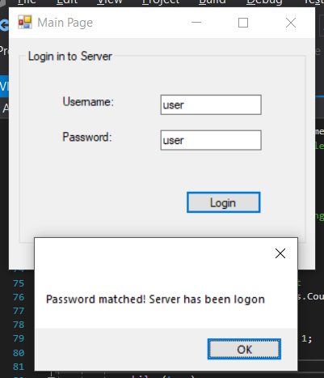

FIGURE 1 – Logon to Server

# Screenshot for Server

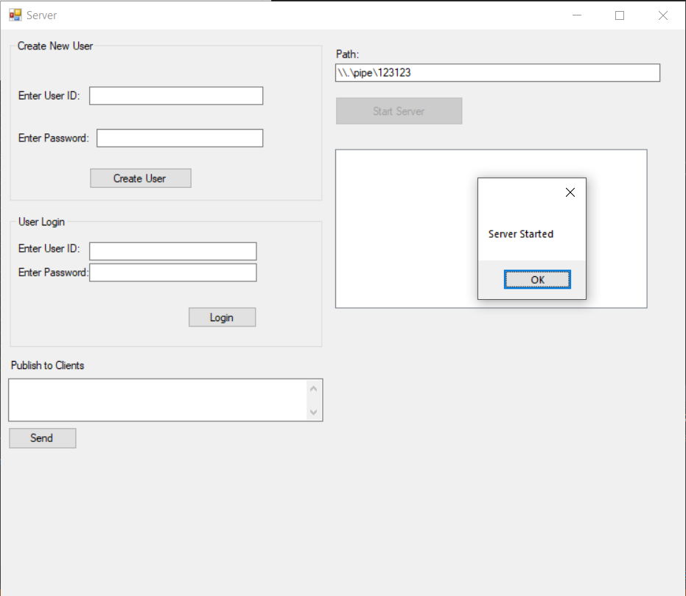

FIGURE 2.1 – Server Started

# 

FIGURE 2.2 – User Created

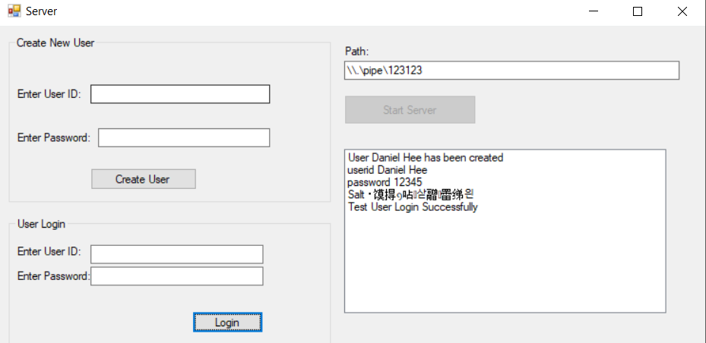

FIGURE 2.3 – Test User Login

# Screenshot for Client

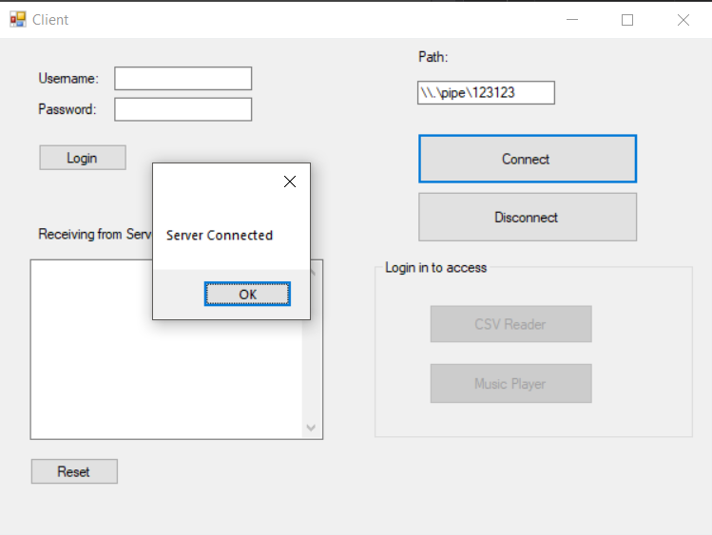

FIGURE 3.1 – Connected to Server

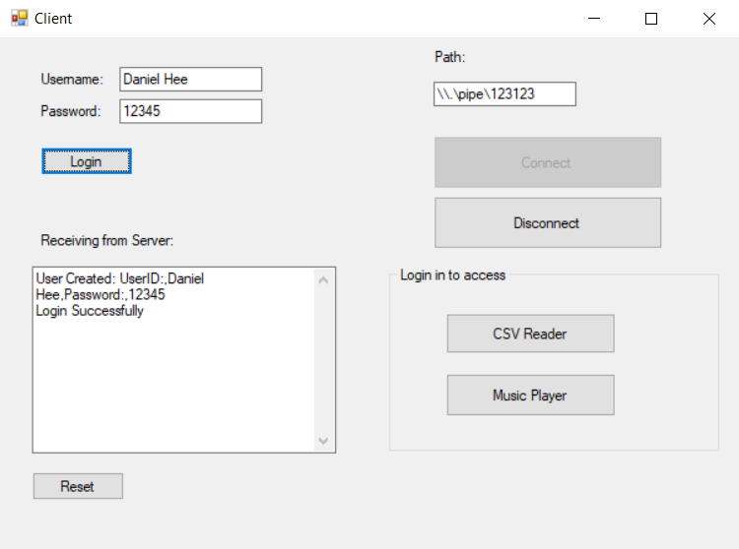

FIGURE 3.2 – User login successfully

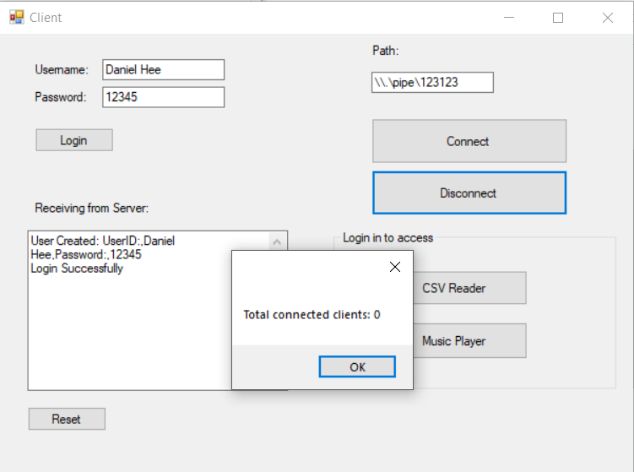

FIGURE 3.3 – Client is disconnected from the Server

# Screenshot for CSVReader

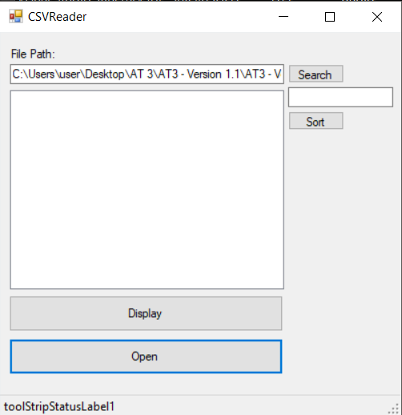

FIGURE 4.1 – Opening a CSV File

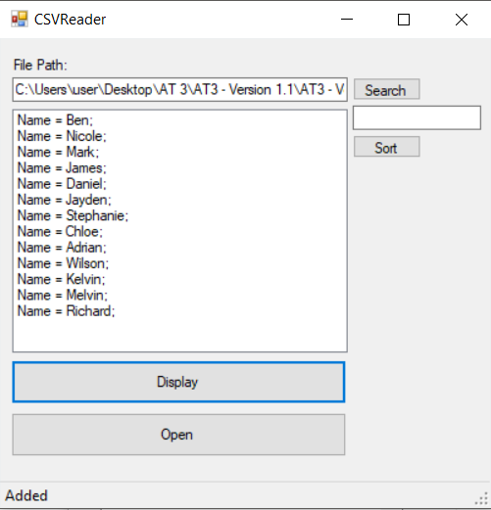

FIGURE 4.2 – Data are added to the List Box from CSV File

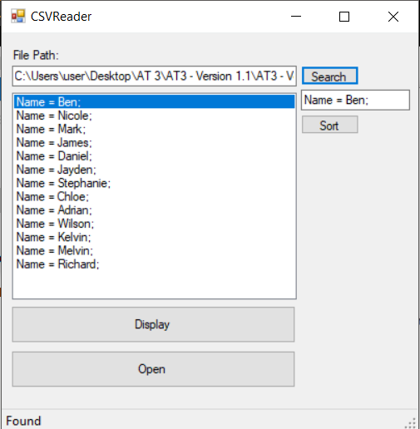

FIGURE 4.3 – Search through the List

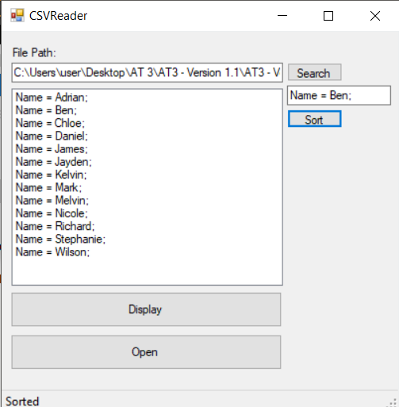

FIGURE 4.4 – List Sorted

# Screenshot for Music Player

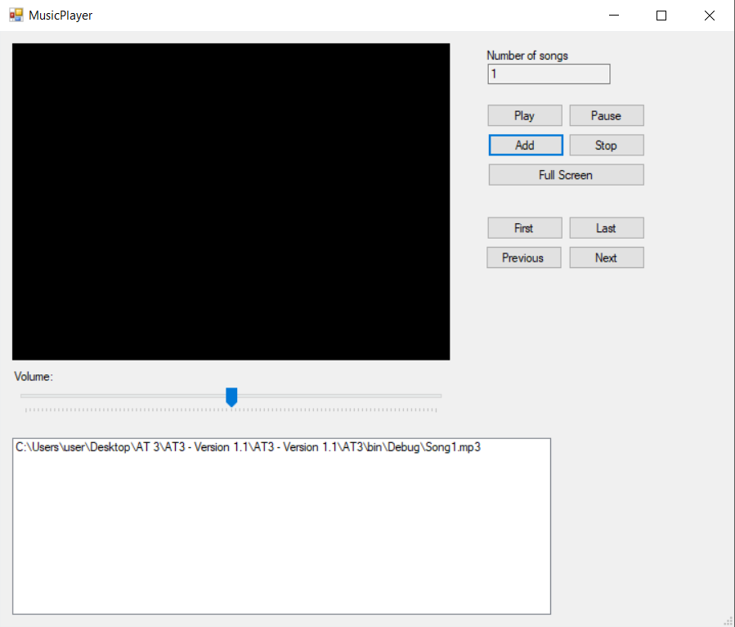

FIGURE 5.1 – Song added to List Box

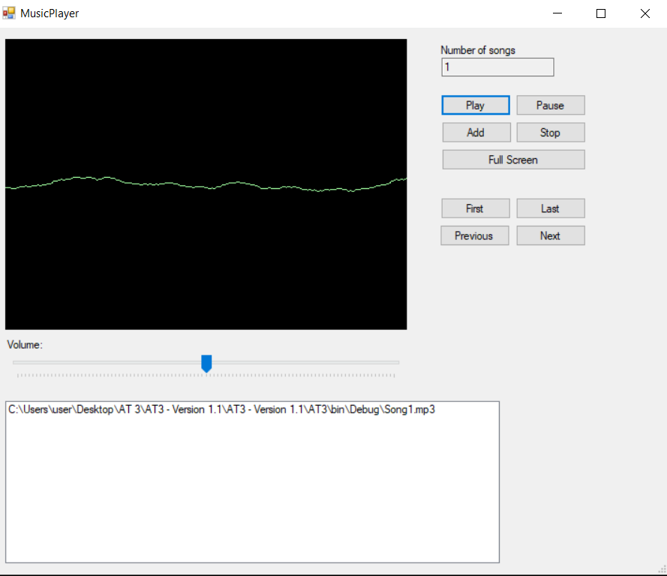

FIGURE 5.2 – Song is Playing

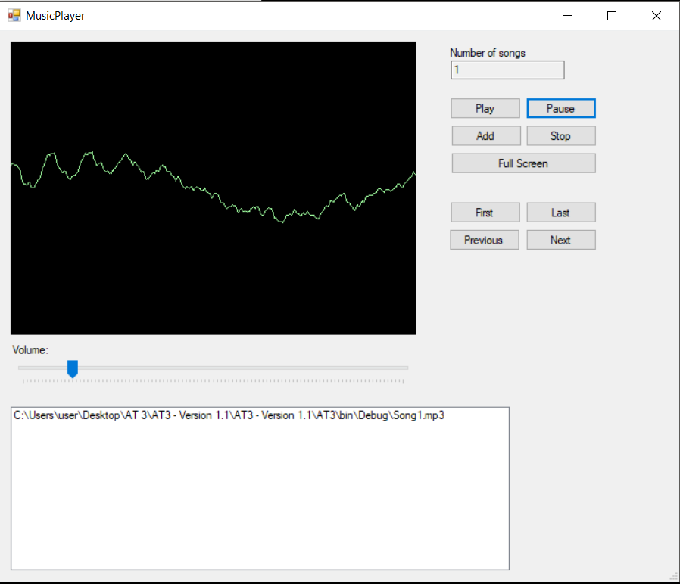

FIGURE 5.3 – Pause Song

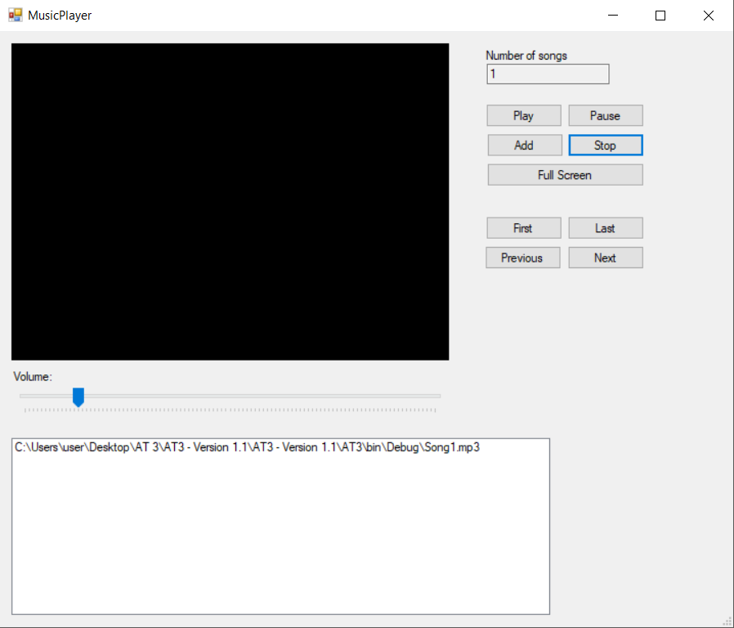

FIGURE 5.4 – Stop Playing Song

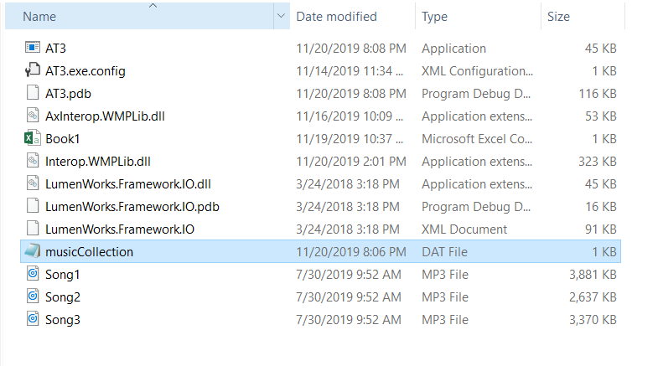

FIGURE 5.5 – Serialization when form closed

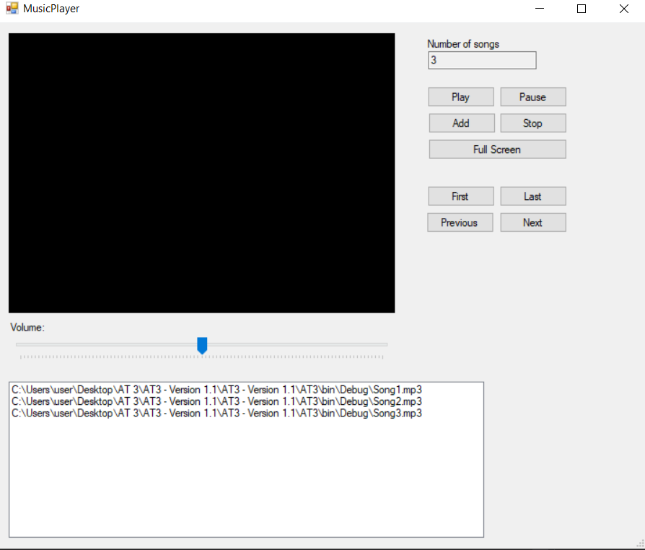

FIGURE 5.6 – Deserialization when form opened and add Music to List Box

# Debugging

Debugging is an important developer tool that attaches to your running app and allows you to inspect your code. It can track down errors in your programmes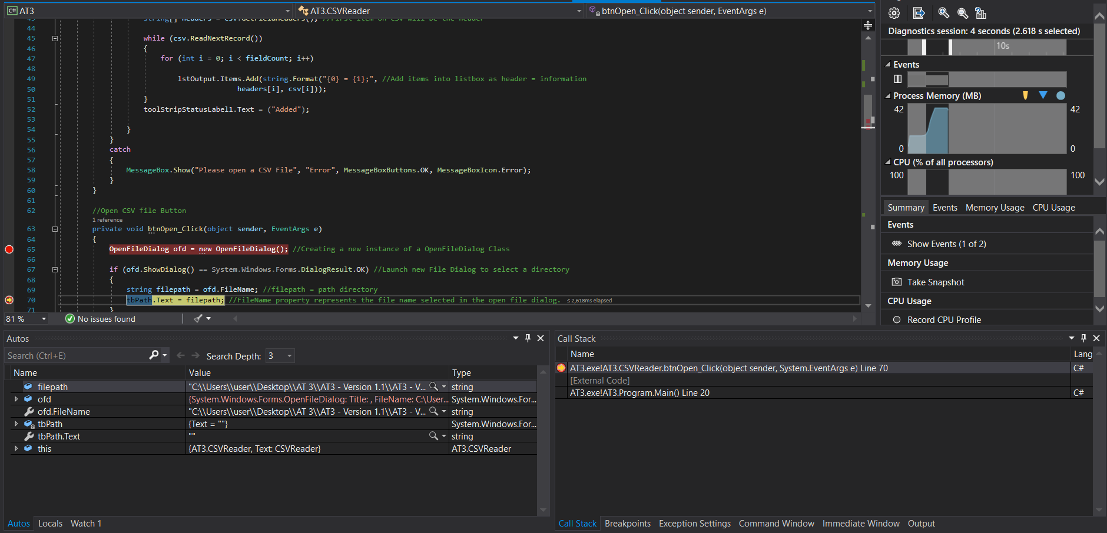

To debug your program, you can add breakpoint to your code and run it. When the program is executed, below will provides information of your code that breakpoint had been added to it.

# Bibliography

*Assessment Coversheet.* (30 May, 2019). Retrieved from BlackBoard: https://blackboard.southmetrotafe.wa.edu.au/bbcswebdav/pid-1071831-dt-content-rid-15292985_1/courses/16_C_EIO_PROG3CLUS_1/Programming%203%20-%20Project%20AT3.pdf

# Glossary of Term

**Comma-Separated Values (CSV)** – This allows data to be saved in a tabular format.

**Graphic User Interface (GUI)** – This is a form of user interface that allows users to interact with electronic devices through graphical icons and audio indicator.